**MUHAMMAD IBRAHIM**

**(46935)**

**REPORT OF 10 CLASSES OF INHERITENCE**

OVERALL CODE OF INHERITENCE:

#include<iostream>

using namespace std;

class one{

public:

string hotel;

void gethotel(){

cout<<"enter the name of hotel:"<<endl;

cin>>hotel;

}

private:

int personid;

void getpersonid(){

cout<<"enter the id of person";

cin>>personid;

}

protected:

int year ;

void getyear(){

cout<<"enter the year of person";

cin>>year;

}

//null constructor

public:

one(){

this->hotel=" ";

this->personid=0;

this->year=0;

}

};

class two: public one {

public:

int personid;

void getpersonid(){

cout<<"enter the id of person:"<<endl;

cin>>personid;

}

private:

string hotel;

void gethotel(){

cout<<"enter the name of hotel:"<<endl;

cin>>hotel;

}

protected:

int year ;

void getyear(){

cout<<"enter the year of person";

cin>>year;

}

//null constructor

public:

two(){

this->hotel=" ";

this->personid=0;

this->year=0;

}

};

class three{

protected:

string hotel;

void gethotel(){

cout<<"enter the name of hotel:"<<endl;

cin>>hotel;

}

private:

int personid;

void getpersonid(){

cout<<"enter the id of person";

cin>>personid;

}

public:

int year ;

void getyear(){

cout<<"enter the year of person";

cin>>year;

}

//null constructor

public:

three(){

this->hotel=" ";

this->personid=0;

this->year=0;

}

};

class four:public three,two,one{

public:

string hotel;

void gethotel(){

cout<<"enter the name of hotel:"<<endl;

cin>>hotel;

}

public:

int personid;

void getpersonid(){

cout<<"enter the id of person";

cin>>personid;

}

public:

int year ;

void getyear(){

cout<<"enter the year of person";

cin>>year;

}

};

int main(){

one hot1;

hot1.gethotel();

two hot2;

hot2.getpersonid();

three hot3;

hot3.getyear();

four hot4;

hot4.gethotel();

hot4.getpersonid();

hot4.getyear();

}

**OUTPUT OF THE CODE IS:**

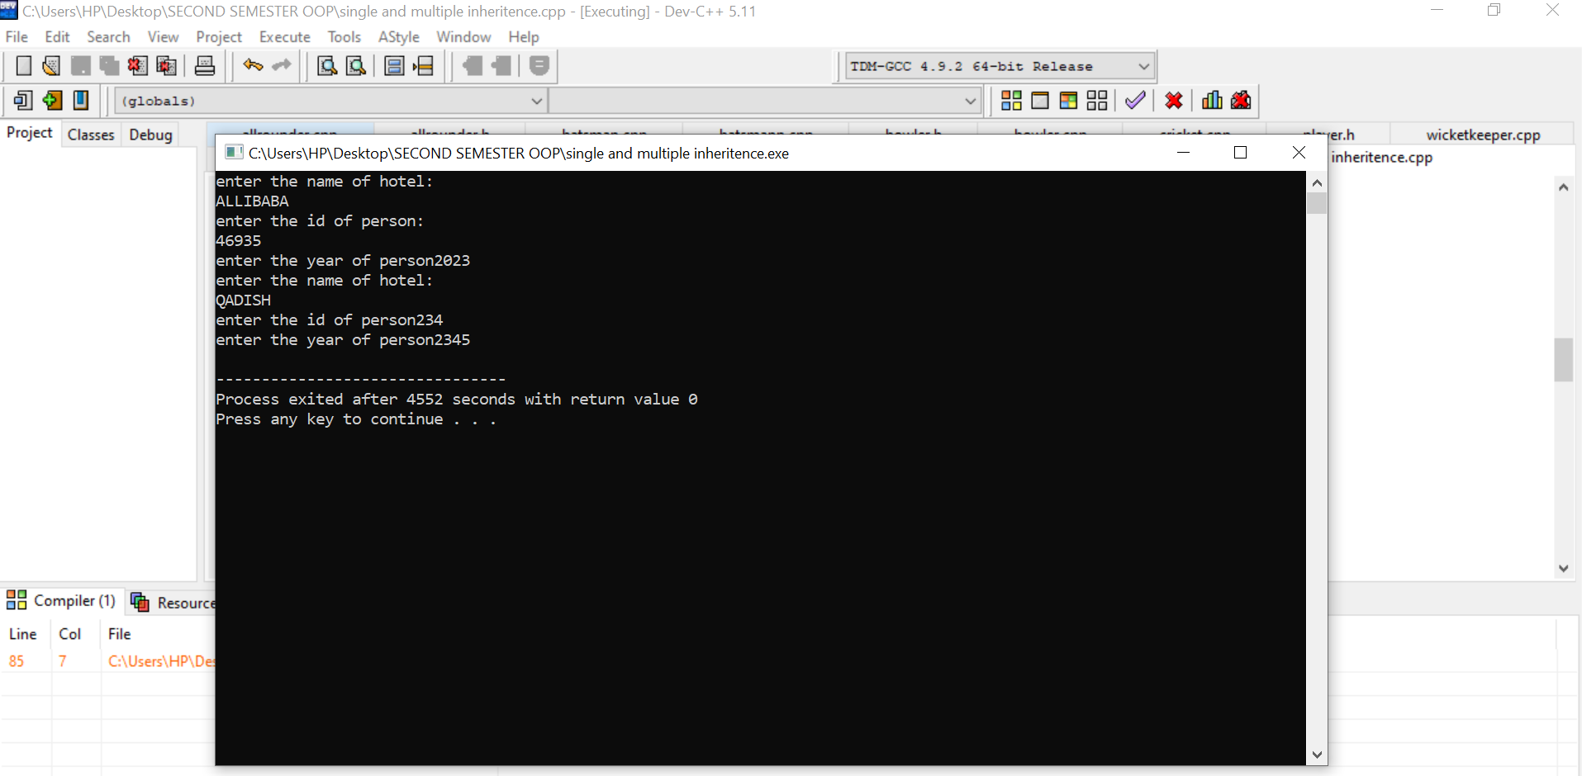

**THE PORTION OF PUBLIC CODES WILL RUN:**

* IN CLASS ONE:

OUTPUT SHOW ON A CONSOLE SCREEN IS :

* ENTER THE NAME OF HOTEl
* IN CLASS TWO:
* ENTER THE ID OF PERSON
* IN CLASS THREE:
* ENTER THE YEAR OF PERSON
* IN CLASS FOUR:
* ENTER THE NAME OF HOTEL
* ENTER THE ID OF PERSON
* ENTER THE YEAR OF PERSON
* OTHER WISE IN CLASS ONE TO FOUR THE PRIVATE AND PROTECTED access modifiers data are not accessable.